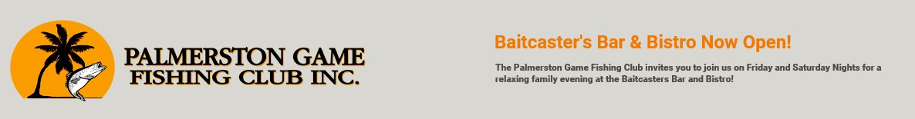

EXPRESSION OF INTEREST
2022 BARRA NATIONALS
Tuesday 3rd May – Tuesday 10th May

Team Name 1st Choice
2nd Choice

Skipper Male / Female

State / Territory Phone
Email

1st Mate Male / Female

State / Territory Phone
Email

2nd Mate Male / Female

State / Territory Phone
Email

3rd Mate (if applicable) Male / Female

State / Territory Phone
Email

Tell us about you & why you want to fish the Barra Nationals - any Barra Nats history? fished other tournaments ? What type of fishing do you do or things of note? Why should you be selected to fish the tournament?

Please email EOI to barranationals@gmail.com
Expressions of interest close 16th July 2021

